ACME Company Air Impact Modeling Analyses Report
Table of Contents

1.0 Summary 3
2.0 Project Description and Background as it Relates to Modeling Analyses 3
2.1 General Facility/Project Description 3
2.2 Location of Project 4
2.3 Existing Permits and Modeling Analyses Performed 5
3.0 Modeling Analyses Applicability and Protocol 6
3.1 Applicable Standards 6
3.2 Criteria Pollutant Modeling Applicability 8
3.3 TAP Modeling Applicability 9
3.4 Modeling Protocol 10
4.0 Modeled Emission Sources 11
4.1 Criteria Pollutants 11
4.1.1 Modeled Emission Rates for Significant Impact Level Analyses 11
4.1.2 Modeled Emission Rates for Cumulative Impact Analyses 12
4.1.3 NO₂/NOx Ratio for NOx Chemistry Modeling 12
4.1.4 Special Methods for Modeling Criteria Pollutant Emissions 12
4.2 Toxic Air Pollutants 12
4.3 Emission Release Parameters 13
5.0 Modeling Methodology 15
5.1 Model Selection 15
5.2 Meteorological Data 16
5.3 Effects of Terrain 16
5.4 Facility Layout 16
5.5 Effects of Building Downwash 18
5.6 Ambient Air Boundary 18
5.7 Receptor Network 18
5.8 Background Concentrations 19
5.9 NOx Chemistry 20
6.0 Results and Discussion 20
6.1 Criteria Pollutant Impact Results 20
6.1.1 Significant Impact Level Analyses 20
6.1.2 Cumulative NAAQS Impact Analyses 20
6.2 TAP Impact Analyses 21
7.0 Quality Assurance/Control 21
8.0 References 21
Attachment 1 – MODELING PROTOCOL AND APPROVAL 22
Attachment 2 – BUILDING DIMENSIONS 23
Attachment 3 – AERMOD INPUTS 24

1.0 Summary

ACME Company (AC) is requesting an air quality Permit to Construct (PTC) for a proposed steel fabrication plant that will be located at 80 N. USA St. in Boise, Idaho 83706.

An air quality impact analysis has been performed in support of this PTC application, as required under IDAPA 58.01.01.200. Idaho regulations require a facility applying for a PTC to demonstrate compliance with the National Ambient Air Quality Standards (NAAQS) and Toxic Air Pollutant (TAP) increments. This Air Impact Analysis Report describes the modeling methodology used and the facility’s impacts to air quality with respect to criteria and TAP emissions. It has been prepared based on the U.S. Environmental Protection Agency (EPA) Guideline on Air Quality Models (EPA, 2017) and the State of Idaho Guideline for Performing Air Quality Impact Analyses (IDEQ, 2013) to support the PTC application.

The modeling analysis includes Toxic Air Pollutants (TAPs) only. All criteria pollutants (particulate matter with an aerodynamic diameter less than or equal to a nominal 10 micrometers (PM₁₀), particulate matter with an aerodynamic diameter less than or equal to a nominal 2.5 micrometers (PM_{2.5}), carbon monoxide (CO), sulfur dioxide (SO₂), nitrogen dioxide (NO₂), lead (Pb), and volatile organic compounds (VOCs)) are categorized as Below Regulatory Concern (BRC) and are exempt from modeling based on facility-wide potential to emit (PTE). Crystalline silica (quartz) is the single TAP modeled in the air quality analysis. Emissions of other TAPs are below Screening Emissions Level (ELs) and did not require modeling.

Facility-wide modeling of TAPs demonstrates that the facility emissions will not cause or contribute to a violation of the Acceptable Ambient Concentration (AAC) for crystalline silica (quartz).

2.0 Project Description and Background as it Relates to Modeling Analyses

The AC fabrication facility will consist of an office, a fabrication shop, a painting shop, and a steel storage area.

2.1 General Facility/Project Description

The steel fabrication process involves the following steps:

- Raw steel will be processed by cutting, welding, and abrasive blasting operations.
- A small percentage of finished structural steel products will be painted in a paint booth.

The facility has five types of operations that produce emissions:

- Heating: Three natural gas heaters will be located at the facility. The facility will operate natural gas heaters unrestricted up to 8,760 hours per year.
- Welding: Welding will be performed inside Shop #1 using hand-held welding torches. Particulate matter emissions will be controlled by a filtration system to control and reduce emissions within the welding area.
- Cutting: A plasma cutter will be fitted with a self-contained dust collector for particulate matter collection.
- Coating: Coating will be performed in a paint booth using a high efficiency HVLP spray gun.
- Abrasive Blasting: Abrasive blasting will be conducted in a booth located within Shop #1, controlled by a baghouse, and vented back into Shop #1.

2.2 Location of Project

The AC facility (Northing: 4,829,056 m; Easting: 564,932 m; UTM Zone 11, NAD83) will be located in Ada County, Idaho. The surrounding land is mostly residential, commercial, and light industrial. Terrain is flat in the immediate vicinity. Ada County is a federally-designated Class II area. It is classified as a maintenance area for particulate matter with an aerodynamic diameter less than or equal to a nominal 10 micrometers (PM₁₀) and carbon monoxide (CO), and an area of concern for particulate matter with an aerodynamic diameter less than or equal to a nominal 2.5 micrometers (PM_{2.5}) and ozone (O₃). While maintenance areas are geographic areas that are previously classified as nonattainment but are now consistently meeting the NAAQS, areas of concern are locations where monitoring data have indicated that compliance with NAAQS is threatened. Ada County is designated as attainment or unclassifiable for sulfur dioxide (SO₂), nitrogen dioxide (NO₂), and lead (Pb).

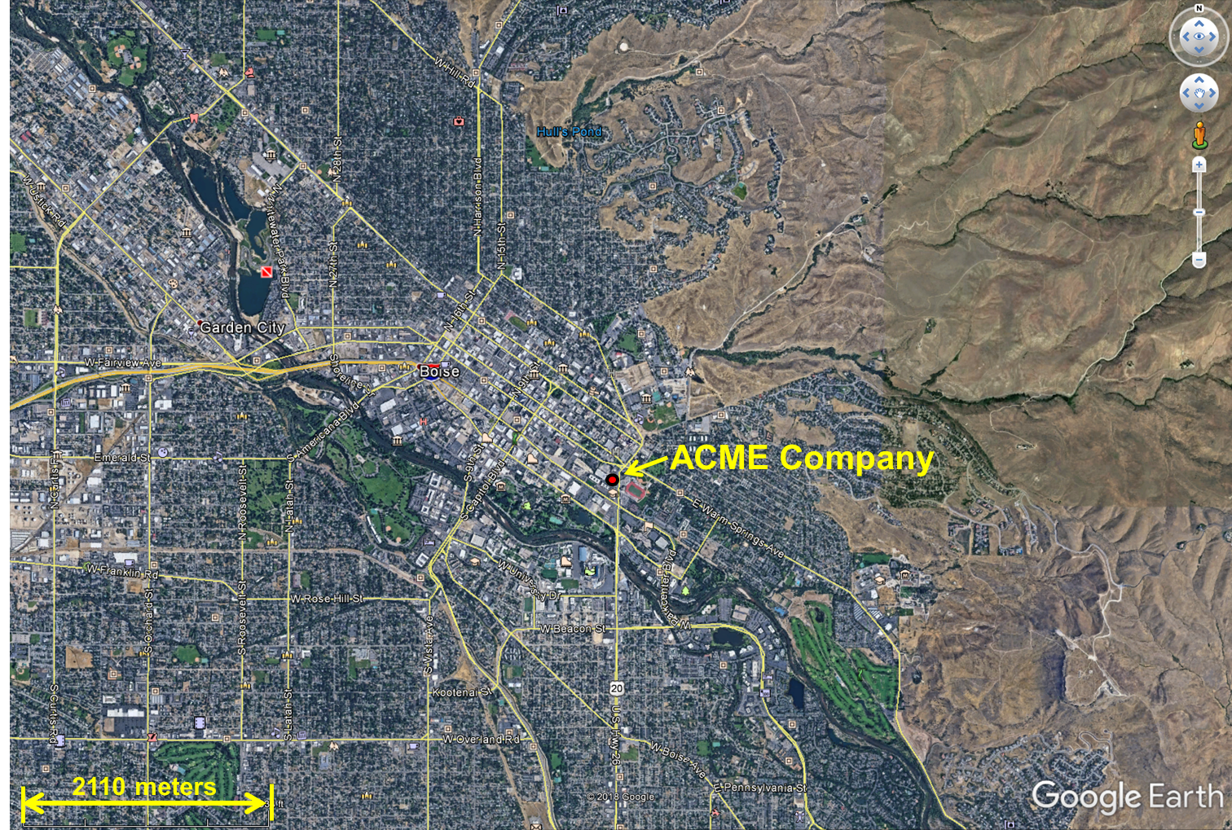
Figure 1. Geographical Location of the ACME Company Facility.

__X__A map showing the geographical location of the facility is provided in this section or a reference is provided to another location in the application where a map is provided.

2.3 Existing Permits and Modeling Analyses Performed

AC is a new facility. No previous modeling analyses have been conducted.

__X__Any existing air quality permits are listed and described in this section, and any associated air quality modeling analyses have been described and referenced, and submitted if appropriate.

3.0 Modeling Analyses Applicability and Protocol

Sections 3.2-3.3 below describe why modeling was performed for each criteria pollutant and TAP.

3.1 Applicable Standards

Criteria pollutant National Ambient Air Quality Standards (NAAQS) are listed in Table 1, along with significant impact levels (SILs).

Table 1. APPLICABLE REGULATORY LIMITS
Pollutant | Averaging Period | Significant Impact Levelsª (μg/m³)^{b} | Regulatory Limit ^{c}  (μg/m³) | Modeled Design Value Used^{d}
PM₁₀e | 24-hour | 5.0 | 150^{f} | Maximum 6th highest^{g}
PM_{2.5}^{h} | 24-hour | 1.2 | 35^{i} | Mean of maximum 8th highest^{j}
PM_{2.5}^{h} | Annual | 0.2 | 12^{k} | Mean of maximum 1st highest^{l}
Carbon monoxide (CO) | 1-hour | 2,000 | 40,000^{m} | Maximum 2nd highest^{n}
Carbon monoxide (CO) | 8-hour | 500 | 10,000^{m} | Maximum 2nd highest^{n}
Sulfur Dioxide (SO₂) | 1-hour | 3 ppbº (7.8 µg/m³) | 75 ppb^{p} (196 µg/m³) | Mean of maximum 4th highest^{q}
Sulfur Dioxide (SO₂) | 3-hour | 25 | 1,300^{m} | Maximum 2nd highest^{n}
Sulfur Dioxide (SO₂) | 24-hour | 5 | 365^{m} | Maximum 2nd highest^{n}
Sulfur Dioxide (SO₂) | Annual | 1.0 | 80^{r} | Maximum 1st highest^{n}
Nitrogen Dioxide (NO₂) | 1-hour | 4 ppb (7.5 µg/m³) | 100 ppb^{s} (188 µg/m³) | Mean of maximum 8th highest^{t}
Nitrogen Dioxide (NO₂) | Annual | 1.0 | 100^{r} | Maximum 1st highest^{n}
Lead (Pb) | 3-month^{u} | NA | 0.15^{r} | Maximum 1st highest^{n}
Lead (Pb) | Quarterly | NA | 1.5^{r} | Maximum 1st highest^{n}
Ozone (O₃) | 8-hour | 40 TPY VOC^{v} | 75 ppb^{w} | Not typically modeled
^{a.} Idaho Air Rules Section 006 (definition for significant contribution) or as incorporated by reference as per Idaho Air Rules Section 107.03.b.
^{b.} Micrograms/cubic meter.
^{c.} Incorporated into Idaho Air Rules by reference, as per Idaho Air Rules Section 107.
^{d.} The maximum 1st highest modeled value is always used for the significant impact analysis unless indicated otherwise. Modeled design values are calculated for each ambient air receptor.
^{e.} Particulate matter with an aerodynamic diameter less than or equal to a nominal 10 micrometers.
^{f.} Not to be exceeded more than once per year on average over 3 years.
^{g.} Concentration at any modeled receptor when using five years of meteorological data.
^{h.} Particulate matter with an aerodynamic diameter less than or equal to a nominal 2.5 micrometers.
^{i.} 3-year mean of the upper 98th percentile of the annual distribution of 24-hour concentrations.
^{j.} 5-year mean of the 8th highest modeled 24-hour concentrations at the modeled receptor for each year of meteorological data modeled. For the SIL analysis, the 5-year mean of the 1st highest modeled 24-hour impacts at the modeled receptor for each year.
^{k.} 3-year mean of annual concentration.
^{l.} 5-year mean of annual averages at the modeled receptor.
^{m.} Not to be exceeded more than once per year.
^{n.} Concentration at any modeled receptor.
^{o.} Interim SIL established by EPA policy memorandum.
^{p.} 3-year mean of the upper 99th percentile of the annual distribution of maximum daily 1-hour concentrations.
^{q.} 5-year mean of the 4th highest daily 1-hour maximum modeled concentrations for each year of meteorological data modeled. For the significant impact analysis, the 5-year mean of 1st highest modeled 1-hour impacts for each year is used.
^{r.} Not to be exceeded in any calendar year.
^{s.} 3-year mean of the upper 98th percentile of the annual distribution of maximum daily 1-hour concentrations.
^{t.} 5-year mean of the 8th highest daily 1-hour maximum modeled concentrations for each year of meteorological data modeled. For the significant impact analysis, the 5-year mean of maximum modeled 1-hour impacts for each year is used.
^{u.} 3-month rolling average.
^{v.} An annual emissions rate of 40 ton/year of VOCs is considered significant for O₃.
^{w.} Annual 4th highest daily maximum 8-hour concentration averaged over three years.

Applicable TAP-specific increment standards are provided in Idaho Air Rules Section 585 and 586. TAP Screening Emission Levels and Acceptable Ambient Concentrations for TAPs present in the facility emissions inventory are identified in Table 2. The facility emissions inventory is provided as an Excel spreadsheet in the PTC Application package.

Table 2. TAP ELS AND AACS/AACCS
TAP | Non-Carcinogen or Carcinogen | Screening Emissions Level (EL)ª  (lb/hr) | AAC or AACC^{b}  (µg/m³)
3-Methylcholanthrene | Carcinogen | 2.50E-06 | 3.70E-04
7-PAH group | Carcinogen | 9.10E-05 | 3.00E-04
Acetone | Non-carcinogen | 1.19E+02 | 8.90E+04
Arsenic | Carcinogen | 1.50E-06 | 2.30E-04
Barium | Non-carcinogen | 3.30E-02 | 2.50E+01
Benzene | Carcinogen | 8.00E-04 | 1.20E-01
Beryllium | Carcinogen | 2.80E-05 | 4.20E-03
Cadmium | Carcinogen | 3.70E-06 | 5.60E-04
Chromium | Non-carcinogen | 3.30E-02 | 2.50E+01
Cobalt | Non-carcinogen | 3.30E-03 | 2.50E+00
Copper | Non-carcinogen | 1.30E-02 | 1.00E+01
Crystalline Silica | Non-carcinogen | 6.70E-03 | 5.00E+00
Dichlorobenzene | Non-carcinogen | 2.00E+01 | 1.50E+04
Formaldehyde | Carcinogen | 5.10E-04 | 7.70E-02
Hexane | Non-carcinogen | 1.20E+01 | 9.00E+03
Iron | Non-carcinogen | 6.70E-02 | 5.00E+01
Manganese | Non-carcinogen | 6.70E-02 | 5.00E+01
Molybdenum | Non-carcinogen | 3.33E-01 | 2.50E+02
Naphthalene | Non-carcinogen | 3.33E+00 | 2.50E+03
Nickel | Carcinogen | 2.70E-05 | 4.20E-03
Other-PAH (exclude 7-PAH)^{c}
Acenaphthene^{c} | Carcinogen | 9.10E-05 | 1.40E-02
Acenaphthylene^{c} | Carcinogen | 9.10E-05 | 1.40E-02
Anthracene^{c} | Carcinogen | 9.10E-05 | 1.40E-02
Fluoranthene^{c} | Carcinogen | 9.10E-05 | 1.40E-02
Fluorene^{c} | Carcinogen | 9.10E-05 | 1.40E-02
Phenanathrene^{c} | Carcinogen | 9.10E-05 | 1.40E-02
Pyrene^{c} | Carcinogen | 9.10E-05 | 1.40E-02
Benzo(g,h,I)perylene^{c} | Carcinogen | 9.10E-05 | 1.40E-02
2-Methylnaphthalene^{c} | Carcinogen | 9.10E-05 | 1.40E-02
7,12-Dimethylbenz(a)anthracene^{c} | Carcinogen | 9.10E-05 | 1.40E-02
Pentane | Non-carcinogen | 1.18E+02 | 8.85E+04
Silicon | Non-carcinogen | 6.67E-01 | 5.00E+02
Toluene | Non-carcinogen | 2.50E+01 | 1.88E+04
Vanadium | Non-carcinogen | 3.00E-03 | 2.50E+00
Zinc | Non-carcinogen | 6.67E-01 | 5.00E+02
^{a.} ELs from Idaho Air Rules Section 585 and 586 in pounds/hour.
^{b.} Acceptable Ambient Concentration (AAC) or Acceptable Ambient Concentration for a Carcinogen (AACC) from Idaho Air Rules Section 585 and 586, in micrograms/cubic meter or milligrams/cubic meter. Note that AACs listed in Idaho Air Rules Section 585 are expressed in units of milligrams/cubic meter rather than micrograms/cubic meter.
^{c.} Polyaromatic Hydrocarbons (PAH's) that are not individually listed in IDAPA 58.01.01.585 or 586 and are not part of IDAPA 58.01.01.586 7-PAH group should be individually compared against the Polyaromatic Hydrocarbons EL of 9.10E-05 lb/hr.

__X__All TAPs identified in the emissions inventory for the project are listed in the TAPs EL and AAC/AACC Table in this section.

3.2 Criteria Pollutant Modeling Applicability

Table 3 lists criteria pollutants for which site-specific modeling analyses were either performed or were not required to demonstrate compliance with NAAQS.

Criteria pollutants were evaluated to establish a potential to emit (PTE) using emission factors from manufacturer’s specifications (when available) or AP-42. See PTE calculations in the submitted emissions inventory for detailed explanation of calculations.

Table 3. MODELING APPLICABILITY
Criteria Pollutant | Modeled (yes/no) | Basis for Exclusion from Modeling
PM_{2.5} 24-hour | No | _X_BRC Exemptª  ___Emissions Below Level l Thresholds^{b}  ___Emissions Below Level II Thresholds^{c}
PM_{2.5} annual | No | _X_BRC Exempt  ___Emissions Below Level l Thresholds  ___Emissions Below Level II Thresholds
PM₁₀ 24-hour | No | _X_BRC Exempt  ___Emissions Below Level l Thresholds  ___Emissions Below Level II Thresholds
NO₂ 1-hour | No | _X_BRC Exempt  ___Emissions Below Level l Thresholds  ___Emissions Below Level II Thresholds
NO₂ annual | No | _X_BRC Exempt  ___Emissions Below Level l Thresholds  ___Emissions Below Level II Thresholds
SO₂ 1-hour, 3-hour | No | _X_BRC Exempt  ___Emissions Below Level l Thresholds  ___Emissions Below Level II Thresholds
SO₂ annual | No | _X_BRC Exempt  ___Emissions Below Level l Thresholds  ___Emissions Below Level II Thresholds
CO 1-hour, 8-hour | No | _X_BRC Exempt  ___Emissions Below Level l Thresholds  ___Emissions Below Level II Thresholds
^{a.} If the project would have qualified for a Category I BRC permitting exemption for the criteria pollutant in question, as per Idaho Air Rules Section 221.01, except for the emissions quantities of another criteria pollutant, then a NAAQS compliance analysis is not required under Section 203.02 or 403.02 for that criteria pollutant.
^{b.} Level I Modeling Thresholds from Table 2 in Section 3 of the DEQ Modeling Guideline. NAAQS compliance is assured through DEQ’s non-site-specific modeling analyses.
^{c.} Level II Modeling Thresholds from Table 2 in Section 3 of the DEQ Modeling Guideline. NAAQS compliance is assured through DEQ’s non-site-specific modeling analyses. Level II Modeling Thresholds can only be used with prior DEQ approval.

__X__Explanations/documentation why modeling was or was not performed for each criteria pollutant are provided in this section.

__X__Emissions calculations that clearly show how the modeling applicability determination was performed are provided in this section.

3.3 TAP Modeling Applicability

Facility-wide TAP emissions were calculated for each emission source, and emission rates were compared to the TAP applicable screening emissions level (EL) listed in IDAPA 58.01.585 and 586. Potential to emit (PTE) was established using emission factors developed from manufacturer’s specifications (when available), products SDSs, and/or AP-42. The maximum operating hours for the AC facility are based on 52 weeks per year of operation, 7 days per week, and 24 hours per day. A maximum of 365 days per year was used to arrive at 8,760 hours per year. See PTE calculations in the submitted emissions inventory for detailed explanations of calculations.

All TAPs with emissions exceeding the EL shown in Table 4 were modeled and compared to either the acceptable ambient concentrations for non-carcinogens (AAC) or acceptable ambient concentrations for carcinogens (AACC). TAPs with PTE below the EL were not considered in the modeling analysis. Crystalline silica (quartz) is the only TAP requiring modeling. Note that TAPs that are HAPs do not require modeling because the facility is subject to a NESHAP, 40 CFR 63 Subpart XXXXXX.

Table 4. ACME COMPANY POTENTIAL TO EMIT (PTE) FOR TOXIC NON-CARCINOGEN AND CARCINOGEN EMISSIONS
TAP | PTE in lb/hr | Screening Emissions Level in lb/hr | Exceeds EL? (Yes or No) | Modeling Required?
3-Methylcholanthrene | 1.41E-08 | 2.50E-06 | No | No
7-PAH group | 8.96E-08 | 2.00E-06 | No | No
Acetone | 3.06E-04 | 1.19E+02 | No | No
Arsenic | 1.57E-06 | 1.50E-06 | Yes | No*
Barium | 3.46E-05 | 3.30E-02 | No | No
Benzene | 1.65E-05 | 8.00E-04 | No | No
Beryllium | 9.43E-08 | 2.80E-05 | No | No
Cadmium | 8.65E-06 | 3.70E-06 | Yes | No*
Chromium | 3.09E-04 | 3.30E-02 | No | No
Cobalt | 6.66E-07 | 3.30E-03 | No | No
Copper | 5.74E-05 | 1.30E-02 | No | No
Crystalline Silica | 1.47E-02 | 6.70E-03 | Yes | Yes
Dichlorobenzene | 9.43E-06 | 2.00E+01 | No | No
Formaldehyde | 5.89E-04 | 5.10E-04 | Yes | No*
Hexane | 1.41E-02 | 1.20E+01 | No | No
Iron | 5.18E-03 | 6.70E-02 | No | No
Manganese | 6.44E-05 | 6.70E-02 | No | No
Molybdenum | 5.37E-05 | 3.33E-01 | No | No
Naphthalene | 4.79E-06 | 3.33E+00 | No | No
Nickel | 9.60E-08 | 2.70E-05 | No | No
Other-PAH (exclude 7-PAH)
Acenaphthene | 1.41E-08 | 9.10E-05 | No | No
Acenaphthylene | 1.41E-08 | 9.10E-05 | No | No
Anthracene | 1.89E-08 | 9.10E-05 | No | No
Fluoranthene | 2.36E-08 | 9.10E-05 | No | No
Fluorene | 2.20E-08 | 9.10E-05 | No | No
Phenanathrene | 1.34E-07 | 9.10E-05 | No | No
Pyrene | 3.93E-08 | 9.10E-05 | No | No
Benzo(g,h,I)perylene | 9.43E-09 | 9.10E-05 | No | No
2-Methylnaphthalene | 1.89E-07 | 9.10E-05 | No | No
7,12-Dimethylbenz(a)anthracene | 1.26E-07 | 9.10E-05 | No | No
Pentane | 2.04E-02 | 1.18E+02 | No | No
Silicon | 6.74E-05 | 6.67E-01 | No | No
Toluene | 2.67E-05 | 2.50E+01 | No | No
Vanadium | 1.81E-05 | 3.00E-03 | No | No
Zinc | 2.28E-04 | 6.67E-01 | No | No
* TAPs that are HAPs (i.e., arsenic, cadmium, and formaldehyde) do not require modeling because this facility is subject to a NESHAP, 40 CFR XXXXXX. See application Form FRA for details.

__X__Explanation/documentation on why modeling was or was not performed for emissions of each TAP identified in the emissions inventory of the application are provided in this section.

3.4 Modeling Protocol

A modeling protocol was submitted to DEQ prior to the application, on March 19, 2018. The protocol was submitted by Consultants and Associates Co. Conditional DEQ protocol approval was provided to Consultants and Associates Co. on April 16, 2018. Project-specific modeling and other required impact analyses were generally conducted using data and methods described in the protocol and in the Idaho Air Quality Modeling Guideline. The protocol and approval notice are included in Attachment 1 of this Modeling Report.

__X__If a protocol was submitted to DEQ prior to performing the modeling analyses, the protocol and DEQ’s conditional protocol approval notice is included in Attachment _1_ of this Modeling Report.

__X__Concerns identified by DEQ in the protocol approval notice have been addressed in the analyses performed and in this Modeling Report.

4.0 Modeled Emission Sources

Painting operations and welding are the only sources of crystalline silica (quartz) at the AC facility. Painting operations are performed in building “Shop #2”, and have been modeled as a single elevated volume source. No forced ventilation or capture of process exhaust is present in this building. The Shop #2 building has three solid side walls and a roof, and is open on the east side. The horizontal location of the source is the approximate center of the open east side of the building, and the release height is one-half the building height. Building dimensions are provided in Attachment 2 of this Modeling Report.

Welding operations are also performed in building “Shop #1.” Particulate matter emissions will be controlled by a RoboVent filtration system. Because no air leaves the building through stacks or ducts connected to the filtration system, controlled welding operations have been modeled as a single elevated volume source. Shop #1 opens to the outside via a single bay door on the east side. A second door on the south side is kept closed at all times, and all emissions are assumed to exit through the east side bay door. The horizontal location of the source is the center of the east side bay door, and the release height is one-half of the door height. Building dimensions are provided in Attachment 2 of this Modeling Report.

__X__The modeling emissions inventory and the emissions inventory presented in other parts of the permit application are consistent, and if they are not identical numbers, it is clearly shown, with calculations submitted, how the modeled value was derived from the value provided in the emissions inventory.

4.1 Criteria Pollutants

Based on the policy that modeling is not required for any criteria pollutant with controlled emissions less than 10% of the significant emission rate, ambient air modeling was not performed for any criteria pollutants for this PTC Application.

4.1.1 Modeled Emission Rates for Significant Impact Level Analyses

This section is not applicable since proposed criteria pollutant emissions are less than BRC levels (less than 10% significant emission rates) and, in accordance with IDEQ modeling guidance, modeling is not required.

__N/A__Emissions rates are identical to those in the model input files for SIL analyses.

__N/A__Calculation of modeled emissions are thoroughly documented in this section, and any unique handling of emissions in the model have been described.

4.1.2 Modeled Emission Rates for Cumulative Impact Analyses

This section is not applicable since proposed criteria pollutant emissions are less than BRC levels (less than 10% significant emission rates) and, in accordance with IDEQ modeling guidance, modeling is not required.

__N/A__Emissions rates in Table X are identical to those in the model input files for the cumulative NAAQS impact analyses.

__N/A__Calculation of modeled emissions are thoroughly documented in this section (unless already described in Section 4.1.1), and any unique handling of emissions in the model have been described.

4.1.3 NO₂/NOx Ratio for NOx Chemistry Modeling

This section is not applicable since proposed NOx emissions are less than BRC levels (less than 10% significant emission rates) and, in accordance with IDEQ modeling guidance, NOx modeling is not required.

4.1.4 Special Methods for Modeling Criteria Pollutant Emissions

This section is not applicable since criteria pollutants were not modeled in this PTC Application.

4.2 Toxic Air Pollutants

Crystalline silica (quartz) is the single TAP requiring modeling in this analysis. The emission rate for crystalline silica (quartz) from painting operations was calculated as follows:

$$Emission rate\left(\frac{lb}{hr}\right)=\frac{Paint throughput\left(\frac{gal}{day}\right)}{\frac{24hr}{day}}*TAP Content \left(weight fraction\right)*Density \left(\frac{lb}{gal}\right)*(1-Paint Gun Transfer Efficiency)$$

The emission rate for crystalline silica (quartz) from welding operations was calculated as follows:

$$Controlled emission rate \left(\frac{lb}{hr}\right)=\frac{Hourly throughput\left(\frac{lb}{hr}\right)}{1000}*EF\left(\frac{lb}{lb of electrode}\right)*TAP Content \left(weight fraction\right)*\left(1-Control Efficiency\right)$$

Equipment specification sheets and SDSs documenting TAP content, density, control efficiency, and transfer efficiency are provided in Appendix B of the PTC Application. Detailed PTE calculations are provided in the submitted emissions inventory.

Table 5 lists TAP emission rates that were included in the modeling analyses. Modeling was performed for each TAP having total project emissions exceeding the TAP-specific Screening Emissions Level (EL).

TABLE 5. MODELED EMISSION RATES FOR TAP ANALYSES
Source ID | Source Description | TAP | Averaging Period | Emissionsª  (lb/hr)
SHOP1 | Welding Operations | Crystalline silica (quartz) | 24-hour | 6.700E-04
SHOP2 | Painting Operations Shop | Crystalline silica (quartz) | 24-hour | 1.401E-02
^{a.} Pounds/hour emissions rate modeled is the project-specific increase in potential/allowable emissions increase for the averaging period specified for the TAP.

__X__TAP emission rates have been listed for each TAP that has project cumulative emissions exceeding the applicable EL.

__X__Emission rates in Table 5 are identical to those in the model input file for TAP analyses.

4.3 Emission Release Parameters

All emissions release parameters have been determined from building design plans and the AERMOD 2016 user guide (EPA, 2016; p.3-83).

The initial vertical dimension for an elevated source on or adjacent to a building is equal to the height of the building (or door opening) divided by 2.15. The initial horizontal dimension is equal to the length of the open side of the building (or door opening) divided by 4.3. The release height is equal to half of the building (or door opening) height, representing the center of mass of the volume source.

For SHOP1:
- $Initial vertical dimension=\frac{20 ft (6.10 m)}{2.15}=9.30 ft (2.83 m)$
- $Initial horizontal dimension=\frac{41 ft (12.50 m)}{4.3}=9.53 ft (2.90 m)$
- $Release height=\frac{20 ft (6.10 m)}{2}=10 ft (3.05 m)$

For SHOP2:
- $Initial vertical dimension=\frac{22.92 ft (6.99 m)}{2.15}=10.66 ft (3.25 m)$
- $Initial horizontal dimension=\frac{70 ft (21.34 m)}{4.3}=16.28 ft (4.96 m)$
- $Release height=\frac{22.92 ft (6.99 m)}{2}=11.46 ft (3.49 m)$

Table 6 lists release parameters for modeled volume sources. Inputs to AERMOD are provided in Attachment 3 of this Modeling Report.

Table 6. VOLUME SOURCE RELEASE PARAMETERS
Source | Description | UTMª  Coordinates |  | Release Height  (m) | Horizontal  Dimension  (m) | Vertical  Dimension  (m)
Source | Description | Easting - X  (m)ª | Northing - Y  (m) | Release Height  (m) | Horizontal  Dimension  (m) | Vertical  Dimension  (m)
SHOP1 | Welding Operations | 564,932.12 | 4,829,056.84 | 3.05 | 2.90 | 2.83
SHOP2 | Painting Operations Shop | 564,925.95 | 4,829,008.62 | 3.49 | 4.96 | 3.25

- Universal Transverse Mercator
- Meters

__X__Thorough justification/documentation of release parameters for all modeled sources is provided in this section.

__X__The specific methods used to determine/calculate given release parameters is described in this section.

__N/A__The release orientation of all point source stacks (horizontal, rain-capped, or uninterrupted vertical release) has been verified and is documented in this section.

5.0 Modeling Methodology

Table 7 summarizes the key modeling parameters used in the impact analyses.

Table 7. MODELING PARAMETERS
Parameter | Description/Values |  | Documentation/Addition Description
General Facility Location | Ada County, ID |  | Ada County is a federally-designated Class II area. It is classified as a maintenance area for PM₁₀ and CO, and an area of concern for PM_{2.5} and O₃. Ada County is designated as attainment or unclassifiable for SO₂, NO₂, and Pb.
Model | AERMOD |  | AERMOD with the PRIME downwash algorithm, Version 18081.
Meteorological Data | The surface and upper air data (2011-2015) are from the Boise Air Terminal (surface met ID: 726810, upper-air ID: 24131). No on-site data were used. |  | The meteorological model input files for this project were developed by IDEQ using AERMET (Version 18081). See Section 5.2 of this memorandum for additional details of the meteorological data.
Terrain | Considered |  | Three-dimensional receptor coordinates were obtained from USGS National Elevation Dataset (NED) files and were used to establish elevation of ground level receptors. AERMAP (Version 18081) was used to determine each receptor elevation and hill-height scale.
Building Downwash | Not considered |  | Building downwash was not considered because no point-type sources were modeled in this analysis.
NOx Chemistry | Not considered |  | NOx was not modeled in this analysis.
Receptor Grid | TAPs Analyses  The ambient air boundary is defined as the fenced perimeter which controls public access to the facility. The selection of receptors in AERMOD were as follows:
Receptor Grid | Grid 1 | Discrete receptors placed every 25 meters along the ambient air boundary.
Receptor Grid | Grid 2 | A 25-meter grid extending at least 50 meters from the ambient air boundary.
Receptor Grid | Grid 3 | A 100-meter grid extending approximately 1 kilometer from the ambient air boundary.
Receptor Grid | Grid 4 | A 500-meter grid extending approximately 5 kilometers from the ambient air boundary.

5.1 Model Selection

The EPA-approved American Meteorological Society/Environmental Protection Agency Regulatory Model (AERMOD, Version 18081) has been used in this air quality analysis. AERMOD is a steady-state plume model that simulates air dispersion based on planetary boundary layer turbulence structure and scaling concepts, including treatment of both surface and elevated sources, and both simple and complex terrain. This model is recommended for short range (< 50 km) dispersion from the source. In this modeling report, AERMOD has been run with the following options:

- Regulatory default options
- Actual receptor elevations and hill-height scales
- Complex/intermediate terrain algorithms

Meteorological data was processed using AERMET (Version 18081), and was provided and approved by IDEQ. Terrain elevation was processed using AERMAP (Version 18081).

__X__The current versions of all models and associated programs were used in analyses, or alternate versions were specifically approved by DEQ.

__X__Any non-default model options used were approved by DEQ in advance.

5.2 Meteorological Data

The IDEQ provided AERMOD-ready meteorological data from Boise, ID for years 2011 through 2015. These data are from the Boise Air Terminal station.

__X__Meteorological data files are provided with the application.

__X__If meteorological data used for modeling were not provided by DEQ, then a detailed discussion of the data is provided along with documentation of the processing steps.

5.3 Effects of Terrain

AERMAP (Version 18081) was used to process terrain elevation data for all sources and receptors using National Elevation Dataset (NED) files prepared by the USGS (using the horizontal datum of NAD83). AERMAP first determines the base elevation at each source and receptor. For complex terrain situations, AERMOD captures the physics of dispersion and creates elevation data for the surrounding terrain identified by a parameter called hill-height scale. AERMAP creates hill-height scale by searching for the terrain height and location that has the greatest influence on dispersion for each individual source and receptor. Both the base elevation and hill-height scale data are produced for each receptor by AERMAP as a file or files that can be directly accessed by AERMOD.

__X__The datum of terrain data, building corner locations, emissions sources, and the ambient air boundary are specified and are consistent such that the modeled plot plan accurately represents the facility and surroundings.

5.4 Facility Layout

Locations of modeled sources (SHOP1 and SHOP2) were determined using knowledge of the site obtained during site visits and placed in the model layout using Google Earth. The horizontal location of SHOP1 is the center of the bay door on the east side of the Shop #1 building. The horizontal location of SHOP2 is the approximate center of the open east side of the Shop #2 building. The ambient air boundary has been placed in the position of the existing physical fenceline using Google Earth satellite imagery. The facility layout is shown in Figure 2 and the ambient air boundary is shown in Figure 3.

All source locations are expressed in the Universal Transverse Mercator North American Datum 1983 (NAD83), Zone 11 coordinate system.

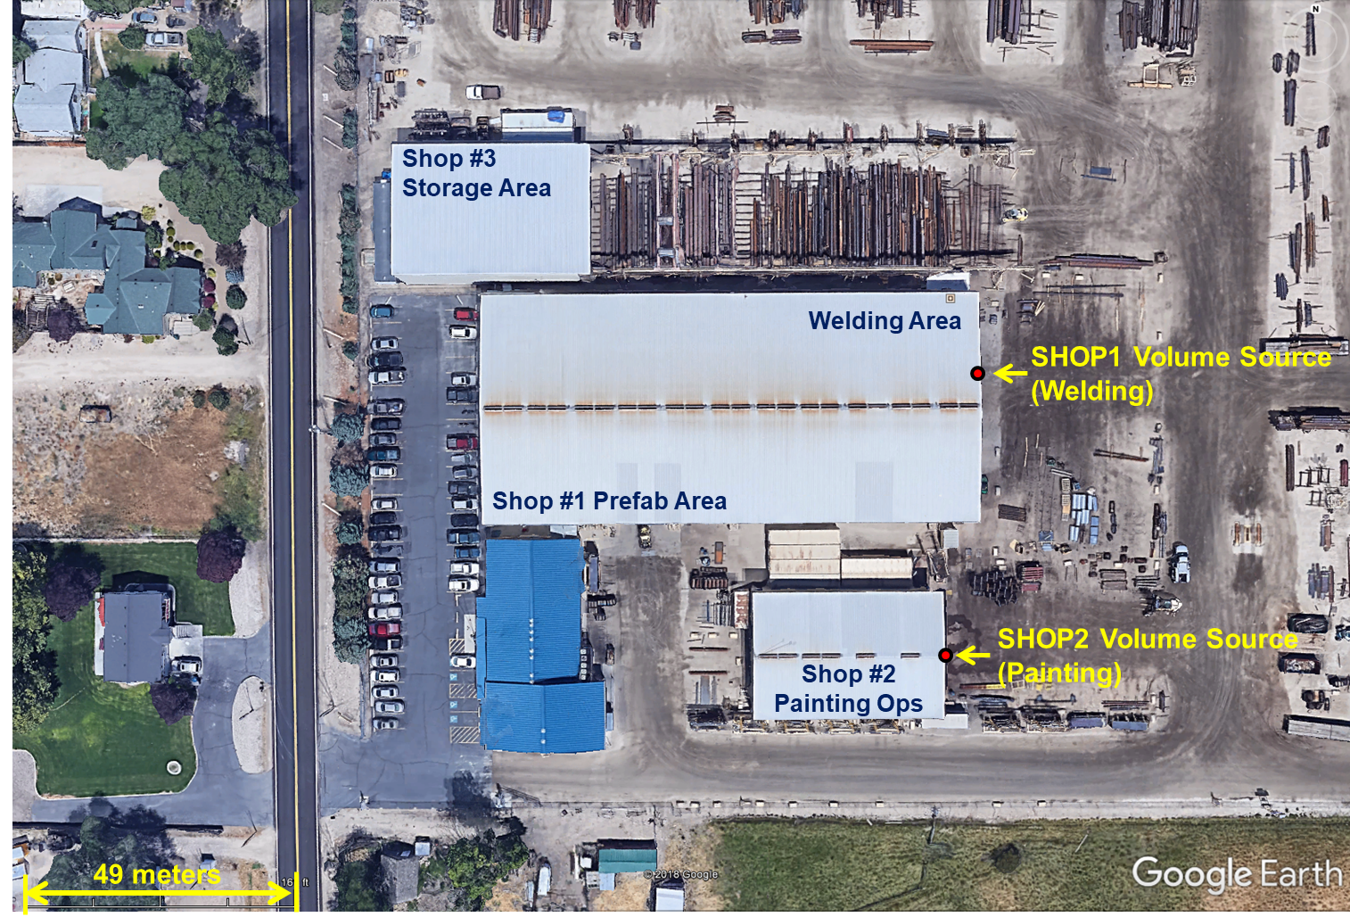
Figure 2. ACME Company Facility Layout.

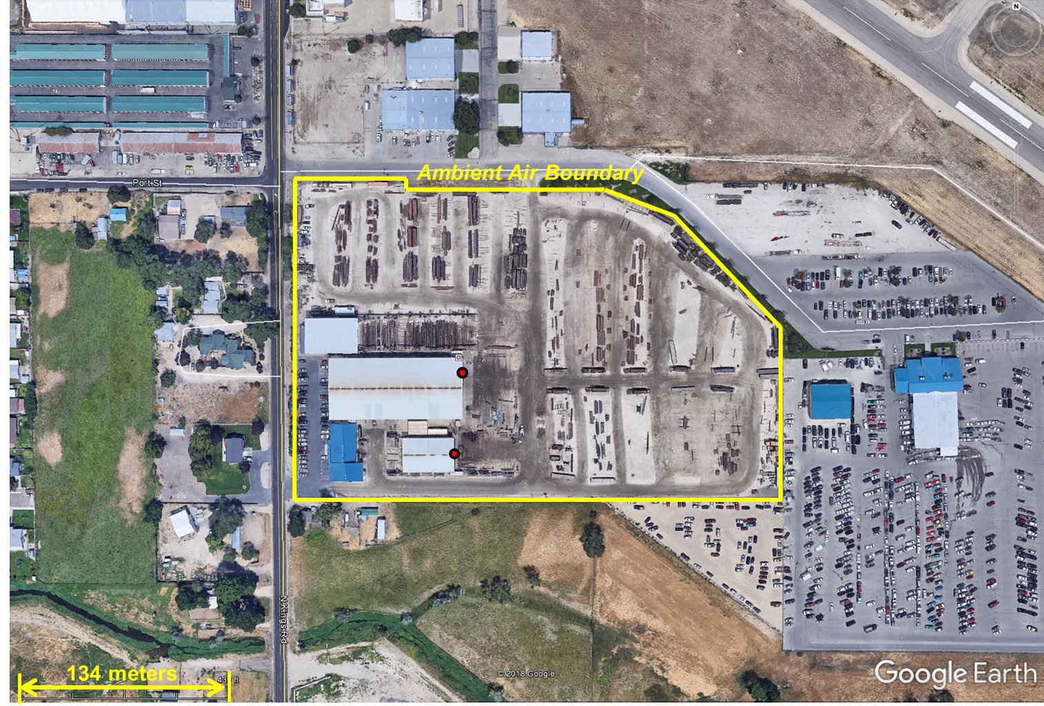
Figure 3. ACME Company Ambient Air Boundary.

__X__The facility layout plot plan is provided in this section that clearly and accurately depicts buildings, emissions points, and the ambient air boundary.

__X__This section of the Modeling Report has thoroughly described how locations of emissions sources, building corners, and the ambient air boundary were determined, specifying the datum used.

5.5 Effects of Building Downwash

Not applicable (emission source is a volume source; no points stacks were modeled in the analysis).

5.6 Ambient Air Boundary

ACME Company controls public access into and throughout the facility using a fenced perimeter. A primary access gate into the facility property along Main Road controls access in and out of the facility. Therefore, the fenced perimeter will be used as the ambient air boundary for modeling purposes, as shown in Figure 3 above.

__N/A__If any of the following apply, the effect on areas excluded from ambient air is thoroughly described in this section: a river/stream bisecting the facility; the facility is on leased property or is leasing property to another entity; the facility is not completely fenced; there are right-of-way areas on the facility; the nature of business is such that the general public have access to part or all of the facility.

__X__This section thoroughly describes how the facility can legally preclude public access (and practically preclude access) to areas excluded from ambient air in the modeling analyses.

5.7 Receptor Network

Discrete receptors were placed every 25 meters along the ambient air boundary (the fenceline which precludes public access to the facility). Additional grids were added as follows:

- A 25-meter grid extending at least 50 meters from the ambient air boundary.
- A 100-meter grid extending approximately 1 kilometer from the ambient air boundary.
- A 500-meter grid extending approximately 5 kilometers from the ambient air boundary.

All receptor locations are expressed in the Universal Transverse Mercator North American Datum 1983 (NAD83), Zone 11 coordinate system.

All receptors for which the design value used for comparison to the AAC is within 50% of the standard are located within the closest (25-meter) grid spacing, and maximum concentrations fall along the fenceline. Maximum modeled concentrations for crystalline silica for the worst-case meteorological year are shown in Figure 4, demonstrating that the grid resolution used is satisfactory to demonstrate TAP compliance.

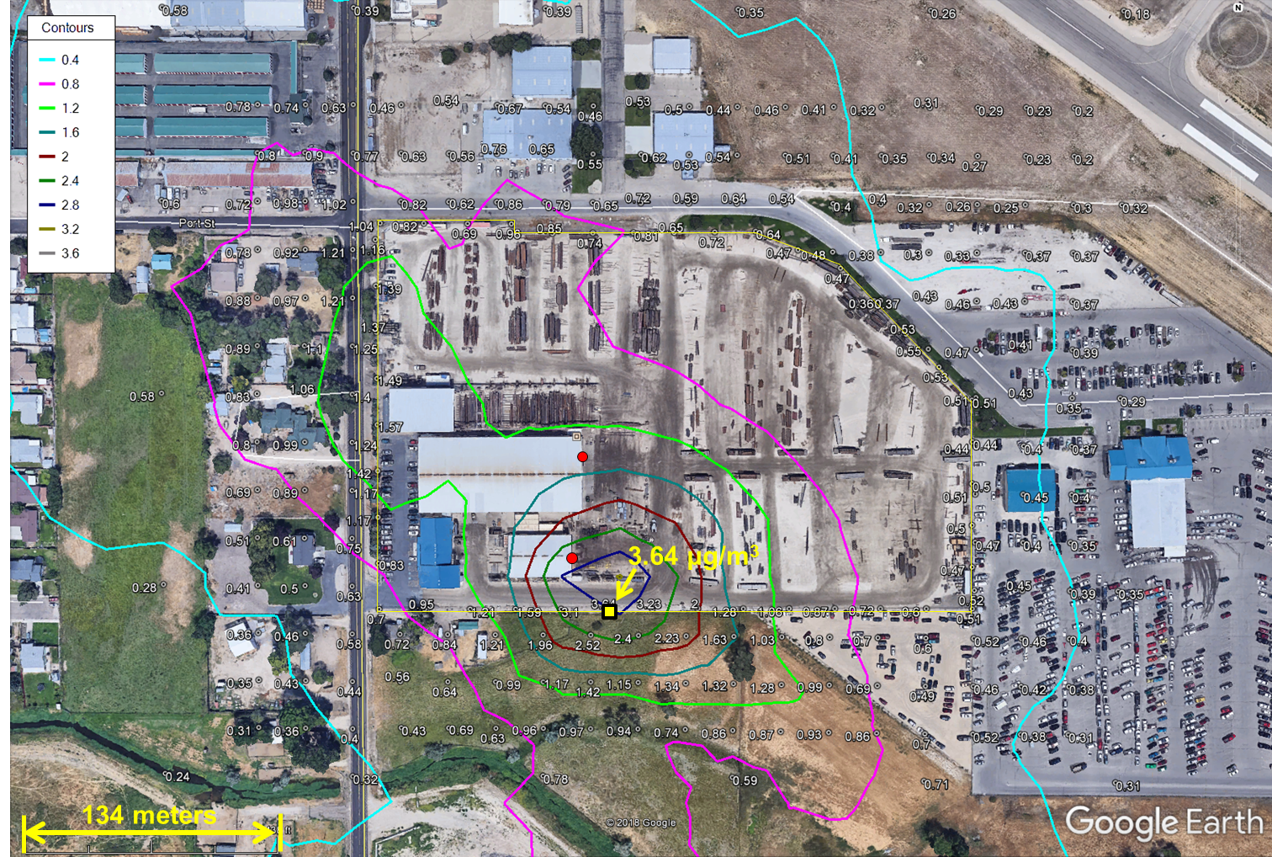
Figure 4. Maximum Modeled 24-Hour Concentrations for Crystalline Silica for the Worst-case Meteorological Year (2014).

__X__This section of the Modeling Report provides justification that receptor spacing used in the air impact analyses was adequate to reasonably resolve the maximum modeled concentrations to the point that NAAQS or TAP compliance is assured.

5.8 Background Concentrations

Not applicable (background concentrations are not required for TAPs modeling).

__N/A__Background concentrations have been thoroughly documented and justified for all criteria pollutants where a cumulative NAAQS impact analysis was performed.

5.9 NOx Chemistry

Not applicable (NOx was not modeled in this analysis).

__N/A__If OLM or PVMRM was used to address NOx chemistry, reasons for selecting one algorithm over the other are provided in this section.

6.0 Results and Discussion

The model output results demonstrate compliance with Idaho Air Rules Section 203.02, 203.03, and/or 403.02. Details of the results are provided in the following sections. All modeling files are provided in electronic form.

6.1 Criteria Pollutant Impact Results

All criteria pollutants fall under the BRC levels. Therefore, modeling was not required.

6.1.1 Significant Impact Level Analyses

Not applicable.

__N/A__Model input and output files for SIL analyses have been provided with the application, with descriptions of the analyses associated with those files.

6.1.2 Cumulative NAAQS Impact Analyses

Not applicable.

__N/A__Model input and output files for the cumulative NAAQS impact analyses are provided with the application.

__N/A__If there were modeled NAAQS violations, all violations were analyzed and clearly show that the project did not significantly contribute to those modeled violations. If there were multiple violations at a given receptor, all cumulative impacts (including background) for the averaging period analyzed were ranked along with the project contribution, and the project contributions were below the applicable SIL. A table was included to show all ranked impacts above the NAAQS along with the project contribution.

6.2 TAP Impact Analyses

Table 8 provides results for TAP impact analyses. The maximum modeled concentration of crystalline silica (quartz) is below the AAC. Therefore, compliance with TAPs increments is demonstrated.

Table 8. RESULTS FOR TAP IMPACT ANALYSES
TAP | Averaging Period | Maximum Modeled Impact (µg/m³)ª | AAC or AACC  (µg/m³)
Crystalline silica (quartz) | 24-hour | 3.64 | 5.00
^{a.} Micrograms/cubic meter.

7.0 Quality Assurance/Control

The modeling analyses and corresponding report have been prepared by air quality professionals experienced in dispersion modeling, and have been peer-reviewed and reviewed by senior Consultants and Associates Co. Air Modeling staff.

8.0 References

Idaho Department of Environmental Quality (IDEQ). 2013. State of Idaho Guideline for Performing Air Quality Impact Analyses. Doc. I D AQ-011. State of Idaho Department of Environmental Quality, Boise, Idaho 83706.

U.S. Environmental Protection Agency (EPA). 2016. User’s Guide for the AMS/EPA Regulatory Model (AERMOD). Office of Air Quality Planning and Standards, Air Quality Assessment Division, Air Quality Modeling Group, Research Triangle Park, North Carolina, December.

U.S. Environmental Protection Agency (EPA). 2017. Appendix W of 40 CFR Part 51 – Guideline on Air Quality Models (Revised), Office of Air Quality Planning and Standards, Research Triangle Park, North Carolina, February.

Attachment 1 – MODELING PROTOCOL AND APPROVAL

The modeling protocol that was submitted to DEQ on March 19, 2018 is attached. A protocol approval letter provided by DEQ on April 16, 2018 is also attached.

Attachment 2 – BUILDING DIMENSIONS

SHOP1 Dimensions

Bay Door Length (ft) | Initial Horizontal Dimension (ft) | Initial Vertical Dimension (ft) | Bay Door Height (ft) | Release Height  (ft)
41 | 9.53 | 9.30 | 20 | 10.00

SHOP2 Dimensions

East Side Length (ft) | Initial Horizontal Dimension (ft) | Initial Vertical Dimension (ft) | Height at Apex of Roof (ft) | Release Height  (ft)
70 | 16.28 | 10.66 | 22.92 | 11.46

Following the AERMOD 2016 User Guide, p. 3-83, the initial vertical dimension for an elevated source on or adjacent to a building is the height of the building divided by 2.15. The initial horizontal dimension is the length of the side of the source (i.e., the open side of the building) divided by 4.3. The release height is taken to be half of the building height, representing the center of mass of the volume source.

Attachment 3 – AERMOD INPUTS

Volume Sources

Source ID | Source Description | Easting (m) | Northing (m) | Base Elevation (m) | Release Height (ft) | Init. Horiz. Dim. (ft) | Init. Vert. Dim. (ft) | Quartz (lb/hr)
SHOP1 | Welding Operations | 564,932.12 | 4,829,056.84 | 768.12 | 10.00 | 9.53 | 9.30 | 0.0006700
SHOP2 | Painting Operations Shop | 564,925.95 | 4,829,008.62 | 767.13 | 11.46 | 16.28 | 10.66 | 0.01401

