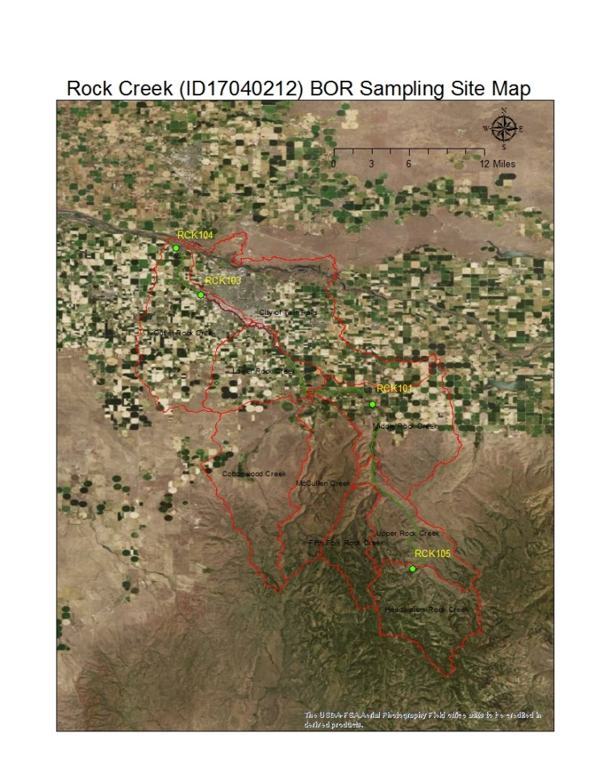

 | Rock Creek at a Glance

Assessment Units

Rock Creek is a major tributary to the Snake River and has been identified as impaired by E. coli, total phosphorus (TP), total suspended solids (TSS), and flow alterations. Monitoring the Rock Creek tributary is important because of its location, history, and pollution issues.

DEQ’s partnership with the Bureau of Reclamation has sustained the monitoring efforts in the Rock Creek watershed for the last 16 years. Four sampling sites have been identified in the interest of assessing water quality conditions and parameters in this tributary to the Snake River. Monitoring efforts have been critical to develop and implement the Total Maximum Daily Load in the Upper Snake Rock watershed.

The following table is an over view of the monitoring locations that were sampled in the federal fiscal year 2019 (FY’19). This monitoring started October 1, 2018 continued through September 30, 2019.
Table 1. Rock Creek monitoring locations.
Location Name | Site Code | Associated AU | Latitude | Longitude
Rock Creek at Mouth | RCK 104 | ID17040212SK013_05 | 42.62088 | -114.53183
Rock Creek at Rock Creek Park | RCK 103 | ID17040212SK013_05 | 42.56517 | -114.50176
Rock Creek at Rock Creek Store | RCK 101 | ID17040212SK016_04 | 42.44132 | -114.30416
Rock Creek at Fourth Fork | RCK 105 | ID17040212SK018_03 | 42.25150 | -114.25816

 | Project Timetable
Samples were collected monthly, starting in October of 2018 and ending in September of 2019. The February monitoring event was cancelled due to unsafe weather conditions. The following table lists the monitoring dates for Rock Creek FY 2019.

Table 2. Summary of monitoring events in fiscial year 2019.
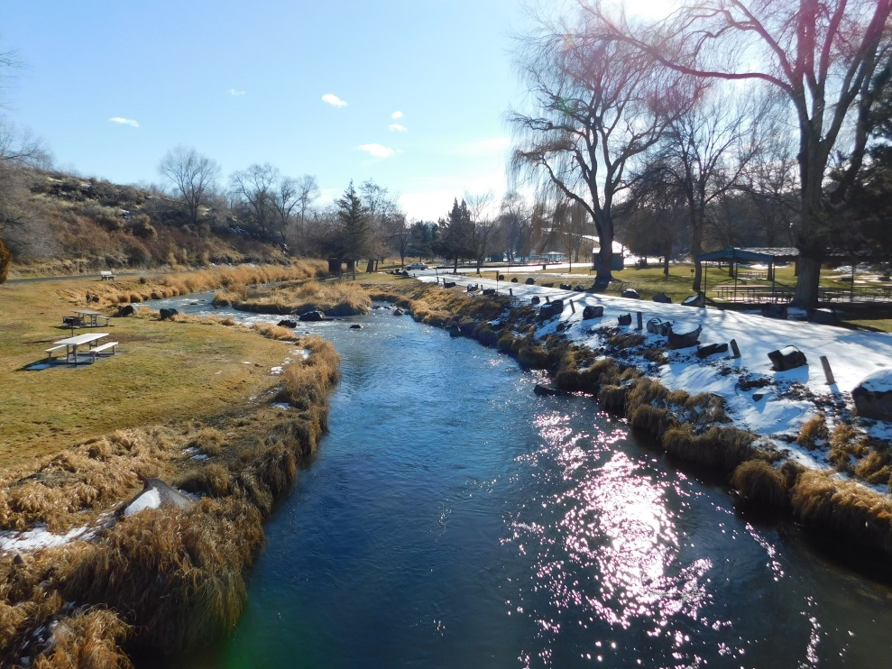 | Monitoring Dates
Wednesday, October 17th
Monday, November 19th
Wednesday, December 12th
Wednesday. January 16th
February – Cancelled due to weather
Wednesday, March 13th
Wednesday, April 17th
Wednesday, May 15th
Wednesday, June 12th
Wednesday, July 17th
Wednesday, August 14th
Wednesday, September 11th

 | Rock Creek TMDL at a Glance

Overview
The Upper Snake-Rock TMDL list Rock Creek impaired for TP, TSS, E.coli, and flow alterations. The TMDL targets for these beneficial uses in the Rock Creek waterbody is as follows: TSS (52 mg/L), TP (0.10 mg/L), and E.coli (406 cfu/100 mL) for primary contact recreation (PCR) and (576 cfu/100 mL) for secondary contact recreation (SCR). Rock Creek monitoring locations RCK 104 and RCK 103 are designated for SCR. Rock Creek monitoring locations RCK 101 and RCK 105 are designated for PCR.

 | Data Summary
The following data, refer to Table 3, is a collection of DEQ’s monitoring on Rock Creek from January 2014 to September 2019. The water quality parameters summarized below include TP, TSS, and E. coli.

Table 3. Summary of data from fiscal year 2019.
Pollutant | TMDL Targets | Number of samples | Average | Number of Exceedances | % Exceedances
TP | 0.10 mg/L | 41 | 0.06 mg/L | 9 | 21.95 %
TSS | 52 mg/L | 39 | 25.46 mg/L | 6 | 15.37 %
E. coli | 406 cfu/100 mL – PCR  576 cfu/100mL – SCR | 39 | 142 MPN/100mL | 1 | 2.56 %
Multi-parameter sonde data was not included in this review.
The following table, Table 4, is a summary of the exceedances for each location and parameter, along with the corresponding dates.
Table 4 below, shows all the corresponding dates of the exceedances described in Table 3.
Sample Location | Site ID | AU ID | Date of Exceedances | Pollutant
Rock Creek at Mouth | RCK 104 | ID17040212SK013_05 | 10/17/2018  4/17/2019  5/15/2019  6/12/2019  8/14/2019 | TP & TSS  TP & TSS  TP & TSS  TP & TSS  TP
Rock Creek at Rock Creek Park | RCK 103 | ID17040212SK013_05 | 4/17/2019  5/15/2019  6/12/2019 | TP & TSS  TP  TP
Rock Creek at Rock Creek Store | RCK 101 | ID17040212SK016_04 | 4/17/2019  6/12/2019 | TP & TSS  E.coli
Rock Creek at Fourth Fork | RCK 105 | ID17040212SK018_03 | --- | ---

Discharge
Flow data collected by DEQ at RCK 103, RCK 101, and RCK 105 is displayed in the following graph; Figure A. Rock Creek at the mouth (RCK 104) flow is an estimation and therefore is not included in this review. The calculated discharge follows the irrigation “pattern”, with peak flows in the spring and fall, and a decline in flow after October to March during the “winter flow”.
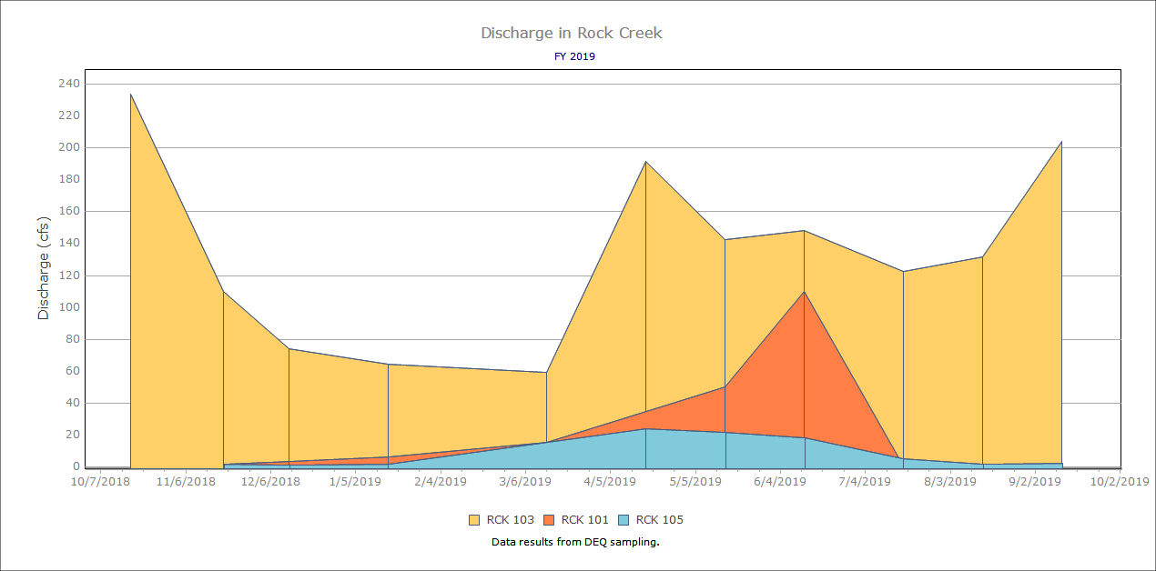
Figure A. Discharge data for fiscal year 2019

Total Phosphorus
Total phosphorus was collected for all four sites. The following table is a summary of the trends over the last five years.
RCK 104 at Mouth | RCK 103 at Park | RCK 101 at Store | RCK 105 at 4th Fork
- Peak in April  - Exceedances March – August  - Decline in late spring to summer  - Incline in August | - Decline in March  - Peak in April/May  - Exceedances in April – July  - Decline around September/October | - Peak in April  - Exceedances in April  - Decline in late spring to summer  - Incline mid-summer  - Decline Fall | - Incline in Spring, around April  - Decline in May back to average concentrations
The following graph, Figure B, shows the trend within the sampling period from 2014-2019. The red line refers to the target of 0.10 mg/L of TP.
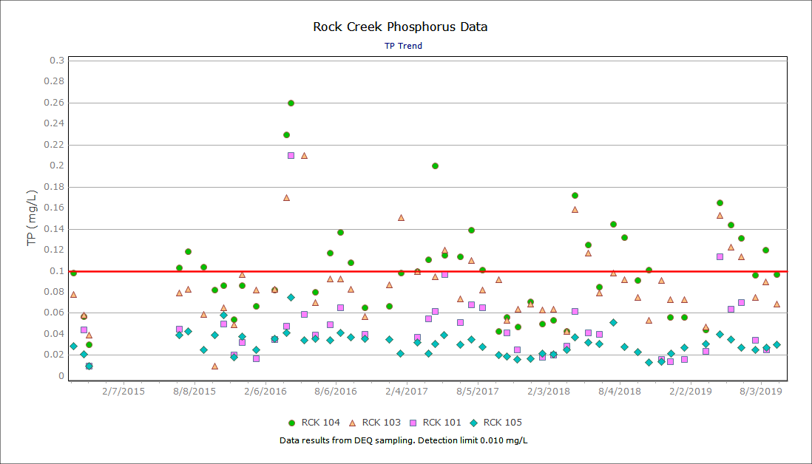
Figure B. Total phosphorus data from January 2014 to September 2019
Figure C is a summary TP collected within the federal fiscal year 2019, starting October 2018 through September 2019. The data shows a peak in TP during April, around the start of the irrigation season.
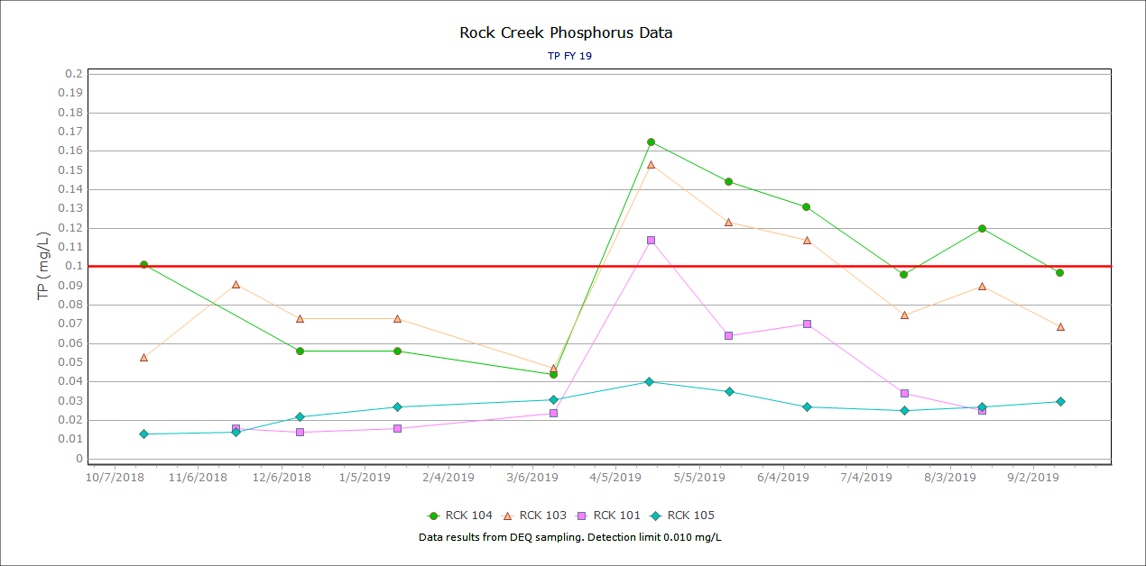
Figure C. Total phosphorus data from October 2018 to September 2019

Total Suspended Solids
The following graph, Figure D, shows the trend within the sampling period from 2014-2019. The red line refers to the target of 52 mg/L of TSS. Note that there were exceedances in April 2016 passed 105 mg/L, therefore are not displayed on the chart. Most exceedances were during late March to May, with a few exceptions.
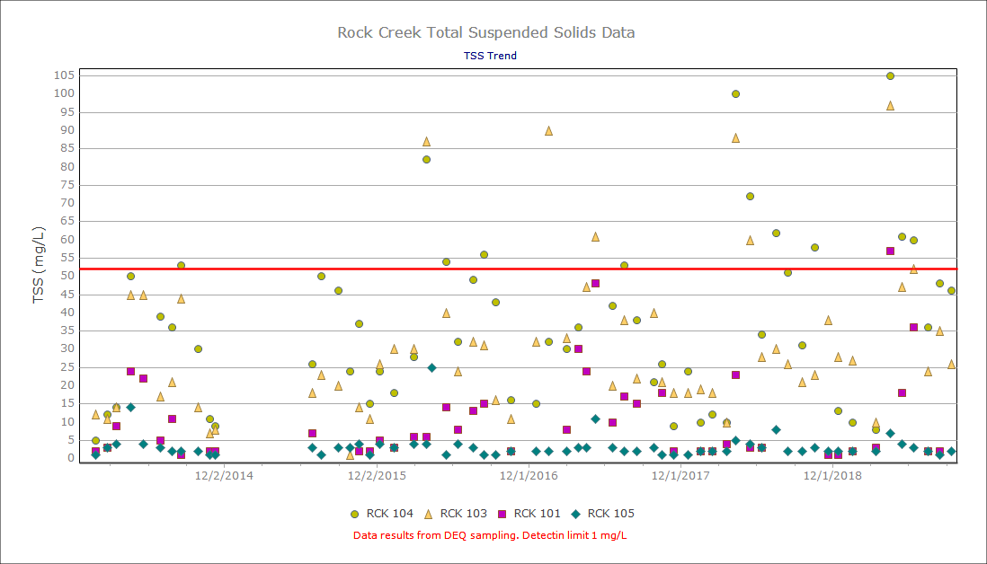
Figure D. Total suspended solids data from January 2014 to September 2019

Figure E is a summary TSS collected within the federal fiscal year 2019, starting October 2018 through September 2019. The data shows a peak in TSS during April, followed by a decline. There is a low trend in TSS during the winter months, as well.
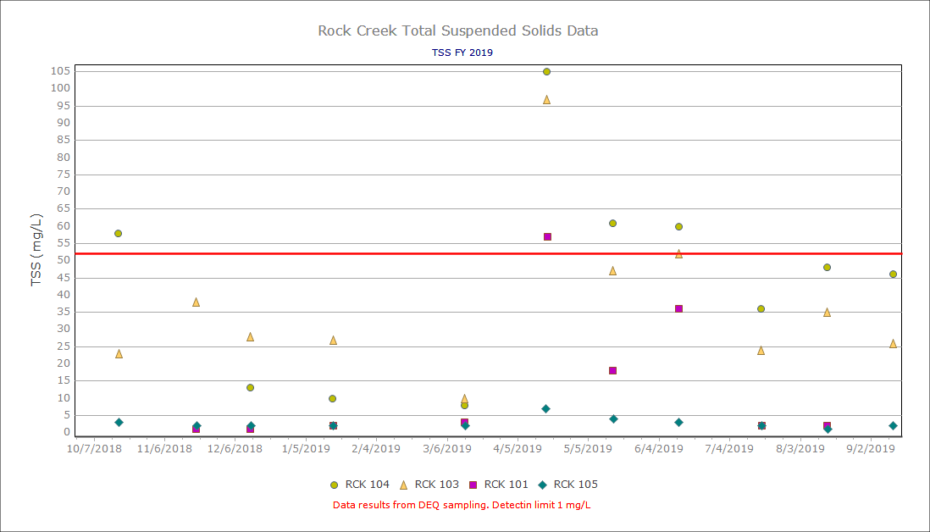
Figure E. Total suspended solids data for FY’19

Nitrate-Nitrite as Nitrogen
The following Figure, Figure F, represents nitrate and nitrite as nitrogen. There is no associated TMDL for nitrate nitrite as nitrogen, therefore there is no target line shown on the following Figure. All values are under 5 mg/L NO₃NO₂.
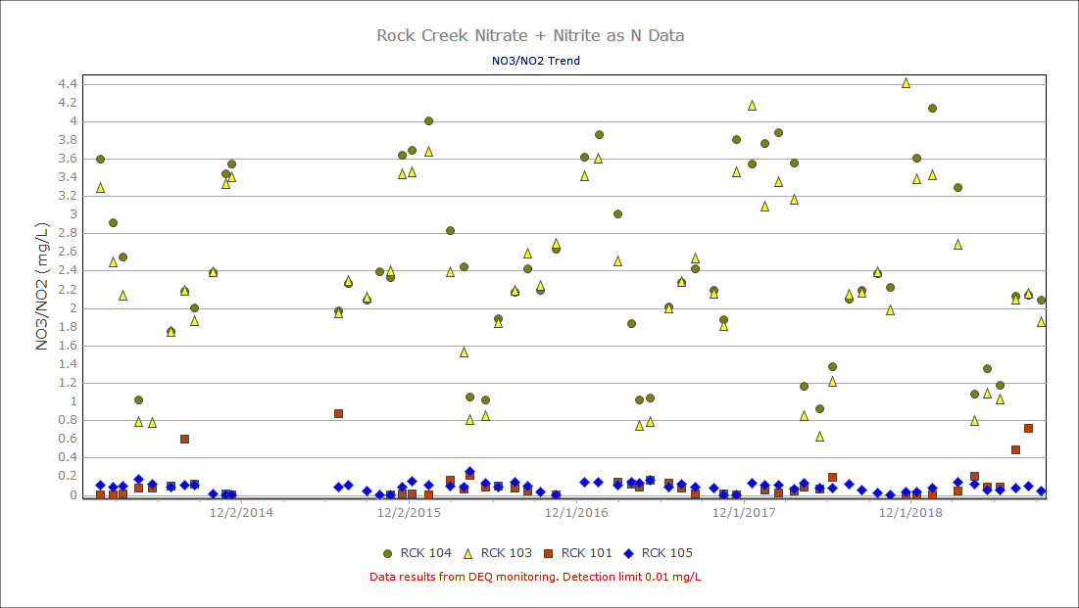
Figure F. Nitrate-Nitrite data from January 2014 to September 2019
Figure G is a summary NO₃NO₂ collected within the federal fiscal year 2019, starting October 2018 through September 2019. The data shows a peak in NO₃NO₂ during the winter months following a decline in spring. There is a second small incline in trend in July.
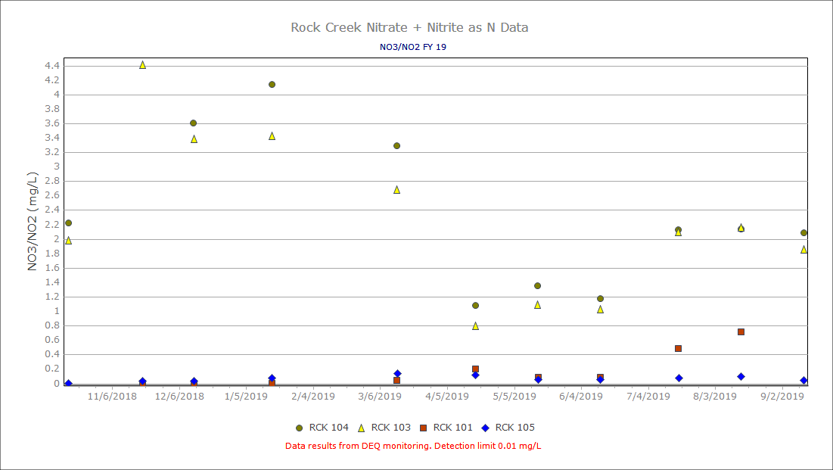
Figure G. Nitrate nitrite as nitrogen data for FY’19

Escherichia coli
E. coli samples were collected for all four sites. The following graph, Figure H, shows the trend within the sampling period from 2014-2019. The red line refers to the target for primary contact recreation of 406 cfu/100mL. RCK 104 and 103 are listed for secondary contact recreation which has a target of 576 cfu/100mL.
There is a rise in in E. coli concentrations around every June/July at each monitoring location for the last 4 years. At RCK 103, the park, there is 3 consecutive years that the E.coli concentrations jump above the secondary contact recreation target (SCR) of 576 cfu/100mL in July, with the following dates of 7/20/2016, 7/18/2017, and 7/18/2018. Similarly, RCK 104, the mouth shows trends that the E.coli concentrations jump above the SCR target on 6/30/2016 and 8/16/2016. The primary contact recreations target (PCR) of 406 cfu/100mL was exceeded at RCK 101, the store, on 6/30/2014, 7/29/2014, 6/30/2015, 6/13/2016, 8/16/2016, 6/20/2017, 7/18/2017, and 6/12/2019. The trend shows that June and July are reoccurring months for E. coli exceedances.
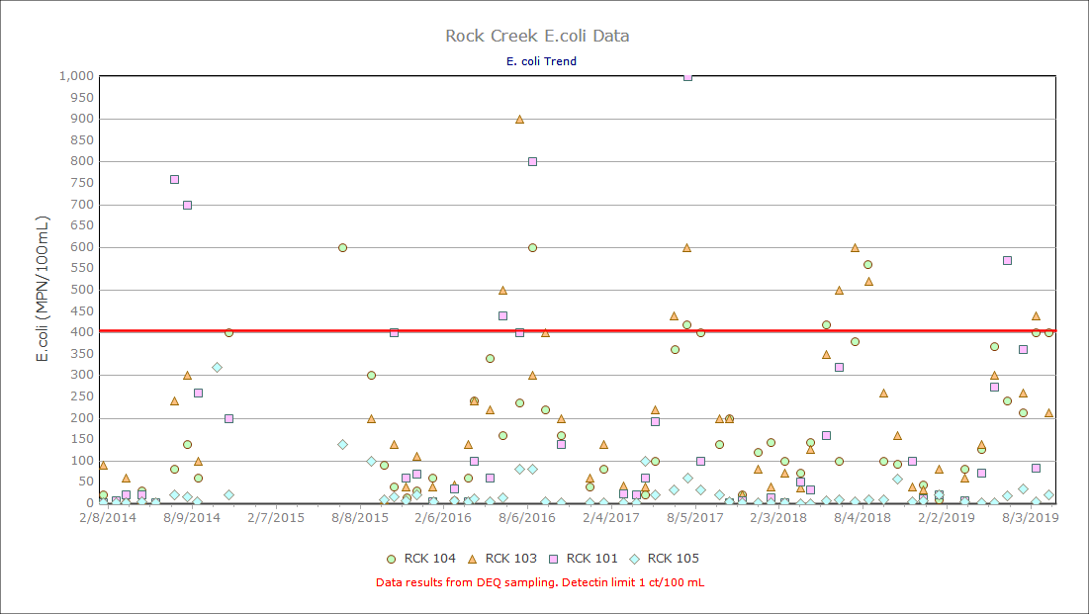
Figure H. E. coli data from January 2014 to September 2019
The following table represents an additional seven sampling events. Figure H, does not include data over 1,000 MPN/100mL
Table 4. Additional E.coli data that was over 1,000 MPN/100mL
Date | Site ID | MPN/100mL
9/30/2014 | RCK 103 | 36,000
9/30/2014 | RCK 104 | 1,380
10/24/2014 | RCK 103 | 2,900
6/30/2015 | RCK 101 | 2,160
6/30/2015 | RCK 103 | 2,800
6/20/2017 | RCK 101 | 1,100
8/16/2017 | RCK 103 | 1,600
Figure I is a summary E.coli collected within the federal fiscal year 2019, starting October 2018 through September 2019. The data shows a peak in E.coli at RCK 104 and 103 in May and August. There is a peak at RCK 101 in June and RCK 105 in July.

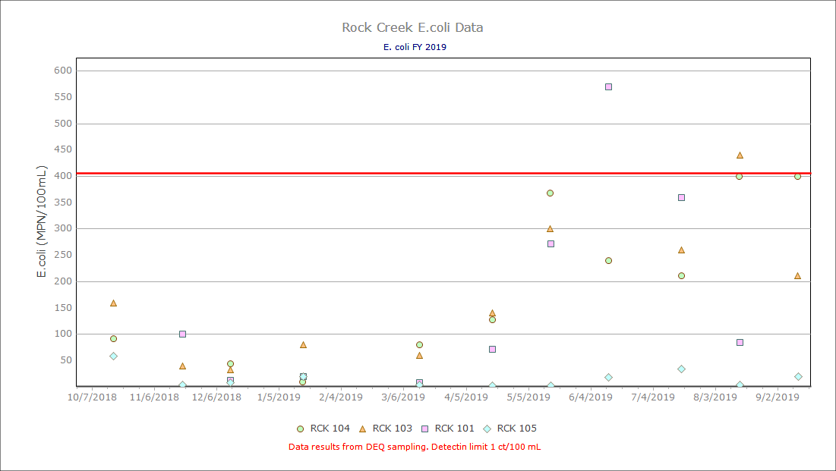
Figure I. E. coli data for FY’19

 | Accomplishments | 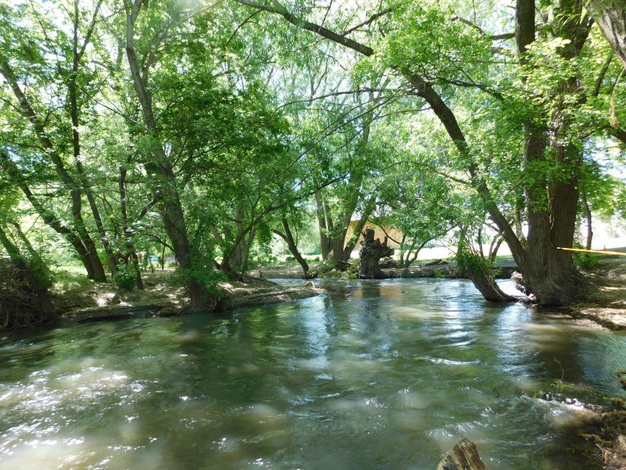
DEQ and BOR continue to have a partnership to further the monitoring efforts in the Rock Creek watershed. This data will be beneficial to support the TMDL efforts in this subbasin.

